Experiment- 5
Branch: MCA (AI&ML) | Semester: 2
Student Name: Ajay Rakwal | UID: 25MCI10329
Subject Name: Technical Training | Subject Code: 25CAP-652
Section/Group: MAM-1(A) | Date of Performance: 24-02-2026

Aim of the program:
To gain hands-on experience in creating and using cursors for row-by-row processing in a database, enabling sequential access and manipulation of query results for complex business logic.

Software Requirements
- Operating System: Windows / Linux
- Database Management System: MySQL / Oracle / PostgreSQL
- SQL Interface: MySQL Workbench /Web Based / pgAdmin

Objective
- Sequential Data Access: To understand how to fetch rows one by one from a result set using cursor mechanisms.
- Row-Level Manipulation: To perform specific operations or calculations on individual records that require conditional procedural logic.
- Resource Management: To learn the lifecycle of a cursor: Declaring, Opening, Fetching, and importantly, Closing and Deallocating to manage system memory.
- Exception Handling: To handle cursor-related errors and performance considerations during large-scale data iteration.

Procedure of the Practical
- Open the database environment such as Oracle / MS SQL Server / PostgreSQL and connect to the desired database.
- Create a sample Employee table and insert records to simulate real-world row-wise data processing.
- Declare a simple forward-only cursor to fetch employee records sequentially and display them one by one.
- Open the cursor and use the FETCH operation to retrieve each row for processing.
- Implement row-by-row manipulation logic such as updating salaries based on specific conditions.
- Handle cursor execution flow by checking for end-of-data or empty result sets to avoid runtime errors
- Properly close and deallocate the cursor after completing all iterations to release system resources.
- Execute the cursor-based blocks and observe sequential processing of records and updates performed.
- Verify the final results using SELECT queries and analyze how cursors enable procedural control over row-wise operations.

Practical / Experiment Steps
--table creation
CREATE TABLE Employee (
emp_id INT,
emp_name VARCHAR(50),
salary INT );
--values insertion
INSERT INTO Employee VALUES (1,'Ajay',20000);
INSERT INTO Employee VALUES (2,'Jatin',15000);
INSERT INTO Employee VALUES (3,'Nidhi',25000);INSERT INTO Employee VALUES (4,'yuvraj',0);
Select * From Employee
--Exception handling performed in multiple lines
BEGIN
INSERT INTO Employee VALUES (4,'Anay',20000);
IF SQL%FOUND THEN
DBMS_OUTPUT.PUT_LINE('ROW INSERT SUCCESSFULLY');
END IF ;
DELETE FROM Employee WHERE emp_id =99;
IF SQL%FOUND THEN
DBMS_OUTPUT.PUT_LINE('ROW DELETE SUCCESSFULLY');
ELSE
DBMS_OUTPUT.PUT_LINE('emp_id NOT FOUND');
END IF ;
END;

Select * From Employee;
-- STEP 1 Forward only cursor
DECLARE
CURSOR emp_cursor IS SELECT EMP_ID,SALARY FROM EMPLOYEE;
V_EMP_ID Employee.EMP_ID%TYPE;
V_SALARY EMPLOYEE.SALARY%TYPE;
SALARY_ZERO EXCEPTION;
BEGIN
OPEN emp_cursor;
FETCH emp_cursor INTO V_EMP_ID ,V_SALARY;
--STEP 2 Row-by-Row Manipulation Logic
WHILE emp_cursor%FOUND
LOOP
IF V_SALARY=0 THEN
RAISE SALARY_ZERO;
END IF
UPDATE EMPLOYEE
SET SALARY=V_SALARY*1.10
WHERE EMP_ID=V_EMP_ID;
FETCH emp_cursor INTO V_EMP_ID ,V_SALARY;
END LOOP
CLOSE emp_cursor;
--STEP 3 exception implemented
EXCEPTION
WHEN SALARY_ZERO THEN
DBMS_OUTPUT.PUT_LINE('Salary is zero. Increment not possible.');

END;
I/O Analysis (Input / Output)
Input
- Employee table creation queries
- Sample data insertion commands
- Cursor declaration and opening statements
- FETCH operations for row-by-row processing
- Conditional UPDATE logic inside cursor loop
- CLOSE and DEALLOCATE cursor commands

Output
- Records fetched sequentially using cursor
- Row-wise salary updates performed correctly
- Cursor lifecycle executed (declare, open, fetch, close, deallocate)
- Proper handling of empty or termination conditions
- Updated records displayed accurately after cursor execution

OUTPUT:
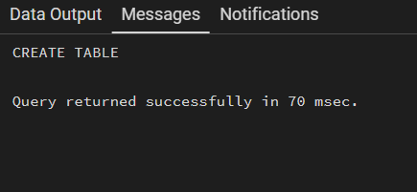
Table Created:

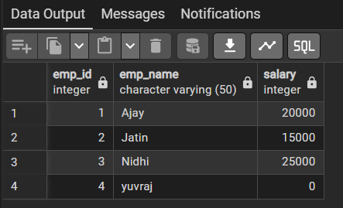
Insert sample records:

--insertion of new entry with the use of exception handling
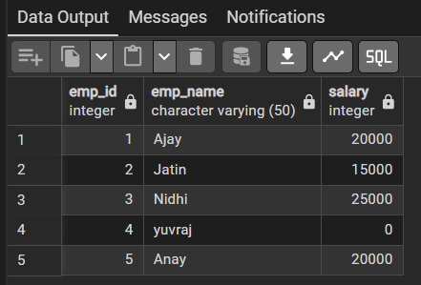

--Implementing cursor lifecycle and exception handling as salary of one entry = 0
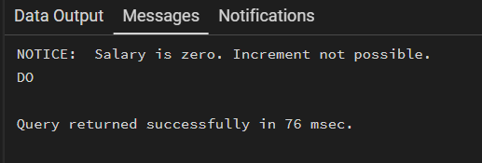

Learning Outcome:
- Understand the concept and need of cursors for row-by-row data processing in databases.
- Learn the lifecycle of cursors including declare, open, fetch, close, and deallocate operations.
- Gain practical knowledge of applying procedural logic to individual records using cursors.
- Develop the ability to handle cursor-related exceptions and manage system resources efficiently.
- Apply cursor-based logic to real-world enterprise scenarios such as payroll updates and data migration tasks.

